Сite: Shevchenko, О. V. (2021). Title of article. Demography and Social Economy, 2 (44), ХХ-ХХ. https://doi.org/10.15407/dse2021.02.0ХХ

https://doi.org/10.15407/dse2021.02.0...
УДК 331.556.4
JEL СLASSIFICATION: J61

O. V. SHEVCHEKO, PhD (Economics), Head of sector
Institute ……………..
Index, Country, City, blvd (str.)……., number house
E-mail: XXXX@XXX.XXX
ORCID 0000-0000-0000-0000
Scopus ID

TITLE
(It is especially important to put the entire essence of the article into the title. It should attract attention and be without an abbreviation (only if it is known). First of all, it is by title that other scientists are looking for the information they need.)
Abstract. With a well-written abstract, researchers will be able to grasp the meaning of the article, get interested in it, and read the entire text. What questions should the abstract reveal: Why and how was the experiment conducted? What results have been obtained subsequently, and what do they mean for science?
Author’s abstract should: explain the study’s approaches, but without methodological details; provide no references and abbreviations. Mandatory guidelines for the abstract: informing character (no general words); well-developed structure (successive logic of description of the article’s findings should be assured); relevant (description of article’s main contents; define the study’s main tasks; summarize the key findings and their importance); detailed definition of the author’s contribution (which positions are developed, proposed, defined, justified, made, revealed, etc.); compact character.
The relevance, purpose, novelty, research methods, main conclusions must be indicated!
Abstract should be within not less than 1,800 printed signs!
The purpose of the article is to ……. It should be noted that ……… It is proved in the article that ……….. This growth was ……………. It is substantiated that …….. The analysis of ………...

Keywords: keyword 1; keyword 2; keyword 3 (List three to ten pertinent keywords specific to the article; yet reasonably common within the subject discipline.)
Introductions. This section should answer several questions: what has already been done in the subject area; what scientists do not yet know; what will be investigated in this article. There should be no water in the introduction. Write down the main tasks and hypotheses of the article.
Relevance of research. The degree of importance of the research topic at the moment and in this situation is determined. This is the ability of the results of work to be applicable to solve significant scientific and practical problems.
The purpose of the article. The aim is to express the main idea of the publication, which differs significantly from modern ideas about the problem, complements or deepens the already known approaches to it; attention is paid to the introduction into scientific circulation of new facts, conclusions, recommendations, patterns. The purpose of the article follows from the formulation of a scientific problem and should correspond to the title and conclusions of the article.
Scientific novelty. Novelty is what represents the result of this work from the results obtained by other authors.
Research methods. In this section, it is necessary to describe the research progress as accurately and correctly as possible, indicating all the details. Then, according to your description, other scientists will be able to repeat the experiment.
This section describes the process of organizing the study, the methods used, the tools used; detailed information about the object of research is given; the sequence of research is indicated and the choice of methods used is substantiated (observation, survey, testing, experiment, analysis, modeling, study, and generalization, etc.).
Analysis of recent research and publications.
When presenting the analysis of publications, the author must describe the main (recent) research and publications on which the author relies; modern views on the problem; difficulties in developing this topic; highlighting unresolved issues within the general problem to which this article is devoted.
The main achievements of modern research of the problem …… are presented in the works of the most famous foreign representatives of economic and social thought, among which: .....
In our opinion, the most detailed study of the problem ……. carried out by specialists ......

Presentation of the main research material. It is necessary to clearly describe all the results obtained with the use of diagrams or tables. This part of the article should be presented systematized author's analytical and statistical material. The results of the study should be described fully enough so that the reader can trace its stages and assess the validity of the conclusions made by the author. This is the main section, the purpose of which is to prove the working hypothesis (hypotheses) by means of analysis, generalization, and explanation of data. If necessary, the results are confirmed by illustrations (tables, graphs, figures), which represent the source material or evidence in a condensed form. It is important that the illustrated information does not duplicate what is already given in the text. It is desirable to compare the results presented in the article with previous works in this field by both the author and other researchers. Such a comparison will further reveal the novelty of the work and give it objectivity.
The results of the study should be summarized, but contain enough information to evaluate the conclusions. It should also be justified why these data were chosen for analysis.
The following are examples of tables and figures. Illustrative data should be in black and white.
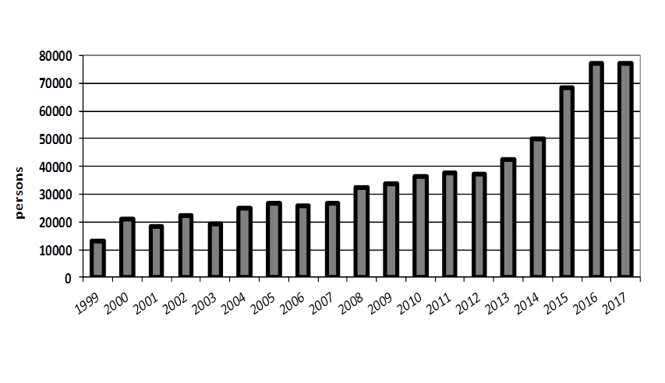
Fig. 1. The dynamics of the number of Ukrainian citizens studying abroad in 1999–2017
Source: UNESCO

Table 1. Scale of External Labor Migration, million
 | 2008 | 2012 | 2017
Nationwide survey data | 1,5 | 1,2 | 1,3
Estimation of total size:  all migrants | 2,1 | 1,9 | 2,7
long-term migrants becoming permanent ones | 0,5 | 0,7 | 1,0
Sources: SSSU, author’s estimation

Examples of formula design:

Extreme Poverty Eradication[Y] = β₀+ β₁X₁ + β₂X₂ + β₃X₃ + β₄X₄ + β₅X₅ + Ɛ (1)

Where: Y = Extreme Poverty Eradication; β₀ = model intercept; X₁ = economic participation of women; X₂ = education of women; X₃ += women’s health care; X₄ = political participation of women, and β₅X₅ = income per capita for the lowest ten percentile (according to World Bank). β₁ – β₅ = model coefficients; Ɛ = error (accounting for other independent variables not accounted for).

Conclusions. The conclusions should contain a brief statement of the results of the study. The main ideas of the main part of the work are repeated in a concise form. The repetitions set out in the conclusions are best illustrated with new phrases that differ from those expressed in the main part of the article. In this section, it is necessary to compare the obtained results with the purpose indicated at the beginning of the work. The conclusions summarize the results of understanding the topic, draw conclusions, generalizations, and recommendations arising from the work, emphasize their practical significance, as well as identify the main areas for further research in this area. In the final part of the article, it is desirable to include attempts to forecast the development of these issues.

REFERENCES

References should contain 18-20 sources. Reference should be made primarily to original sources from scientific journals included in global citation indices. It is important to correctly link to the source. The authors' surnames, journal (web address), year of publication, volume (issue), number, pages, DOI or Internet access address, date of access to the electronic source should be indicated. The reader should be able to find the specified literary source in the shortest possible time.
References must be issued according to the international bibliographic standard APA-2010.

1. Cherenko, L. M. (2018). Zhytlovi umovy naselennya Ukrayiny ta vybir priorytetnykh napryamiv zhytlovoyi polityky [Housing conditions of the population of Ukraine and the choice of priority areas of housing policy]. Demohrafiia ta sotsialna ekonomika - Demography and Social Economy, 1 (32), 126-139. https://doi.org/10.15407/dse2018.02.126 [in Ukrainian]
2. Pishhyk, O. V. (2018). Etapy formuvannya stratehiyi sotsial'noho rozvytku terytoriyi u zabezpechenni zhytlom naselennya [Stages of formation of the strategy of social development of the territory in providing housing for the population]. Biznes-navigator - Business Navigator, 1-2, 80-84 [in Ukrainian].
3. Norman, D. (2001). Europe A History (P. Tarashhuk, & O. Kovalenko, Trans). Kyiv: Osnovy [in Ukrainian].
4. Statystychnyi shchorichnyk Ukrainy za 2018 rik [Statistical Yearbook of Ukraine for 2018] (2019). Derzhavna sluzhba statystyku Ukrainy. www.ukrstat.gov.ua Retrieved from http://www.ukrstat.gov.ua/ [in Ukrainian].
Article submitted on 00.00.2021.

O. V. Shevcheko, PhD (Economics), Head of sector – in Ukrainian
Institute …………….. - in Ukrainian
Index, Country, City, blvd (str.)……., number house - in Ukrainian
E-mail: XXXX@XXX.XXX
ORCID 0000-0000-0000-0000
Scopus ID

TITLE (in Ukrainian)

Abstract. (translated in Ukrainian)

Keywords: (translated in Ukrainian)

TECHNICAL REQUIREMENTS:
The maximum volume of the article is 25 pages (together with abstracts and references).
All margins should be 2 cm, paragraph - indent 1.25 cm.
Font - Times New Roman, 14 (for the main text) and Times New Roman, 12 (for figures, tables, sources, data on authors, abstracts and references).
Interval - 1.5 (for the main text) and 1.3 (for figures, tables, sources, data on authors, abstracts and references).

